[Rotate Image - LeetCode](https://leetcode.com/problems/rotate-image/description/)

[Rotate Image - LeetCode](https://leetcode.com/problems/rotate-image/solutions/1175496/js-python-java-c-easy-4-way-swap-solution-w-explanation/?orderBy=most_votes&languageTags=java)

You are given an n x n 2D matrix representing an image, rotate the image by **90** degrees (clockwise).

You have to rotate the image [**in-place**](https://en.wikipedia.org/wiki/In-place_algorithm), which means you have to modify the input 2D matrix directly. **DO NOT** allocate another 2D matrix and do the rotation.

**Example 1:**

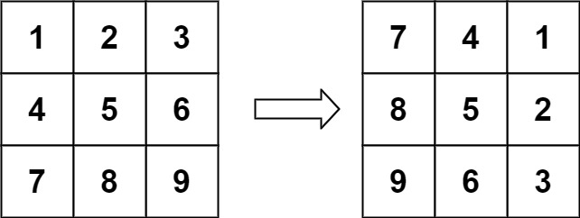

**Input:** matrix = [[1,2,3],[4,5,6],[7,8,9]]

**Output:** [[7,4,1],[8,5,2],[9,6,3]]

class Solution {

    public void rotate(int[][] matrix) {

        int n = matrix.length;

        for (int i = 0; i < (n + 1) / 2; i ++) {

            for (int j = 0; j < n / 2; j++) {

                int temp = matrix[n - 1 - j][i];

                matrix[n - 1 - j][i] = matrix[n - 1 - i][n - j - 1];

                matrix[n - 1 - i][n - j - 1] = matrix[j][n - 1 -i];

                matrix[j][n - 1 - i] = matrix[i][j];

                matrix[i][j] = temp;

            }

        }

    }

}